Chapter 14, Solution 43.

- 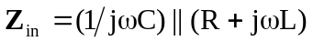

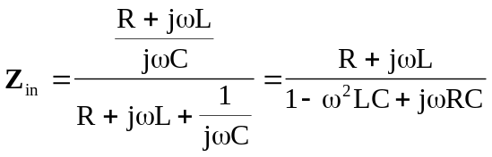
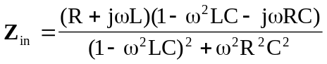

At resonance, 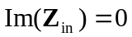, i.e.
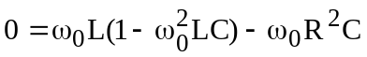
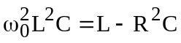
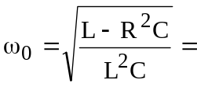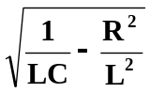

- 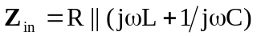

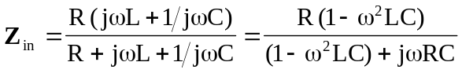
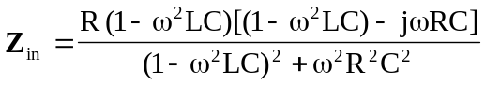

At resonance, , i.e.
